**MURATA DEVICES**

**1) PE23108-R01 :**

**Device Plugin Used:**

* ARCxC0608Control

**GUI Panels:**

* Command
* Status
* Configuration

**Visual Appearance :**

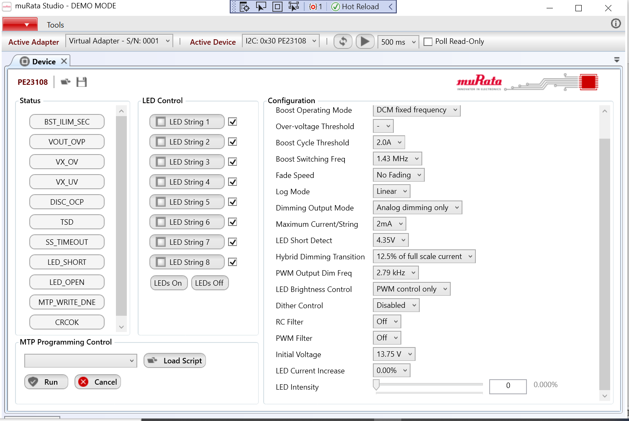

**2) PE24106-R01**

**Device Plugin Used:**

* PE24106Control

**GUI Panels:**

1. Config1Panels
   * + Buck1 Control
     + ADC Output
     + ADC Configuration
     + Configuration
     + Faults
     + Slave1 Status
     + Slave2 Status
2. Config2Panels
   * + Buck1 Control
     + ADC Output
     + ADC Configuration
     + Configuration
     + Faults
     + Slave1 Status

Slave2 Status

1. Config3Panels
   * + Buck1 Control
     + ADC Output
     + ADC Configuration
     + Configuration
     + Faults
     + Slave1 Status
     + Slave2 Status

**Visual Appearance :**

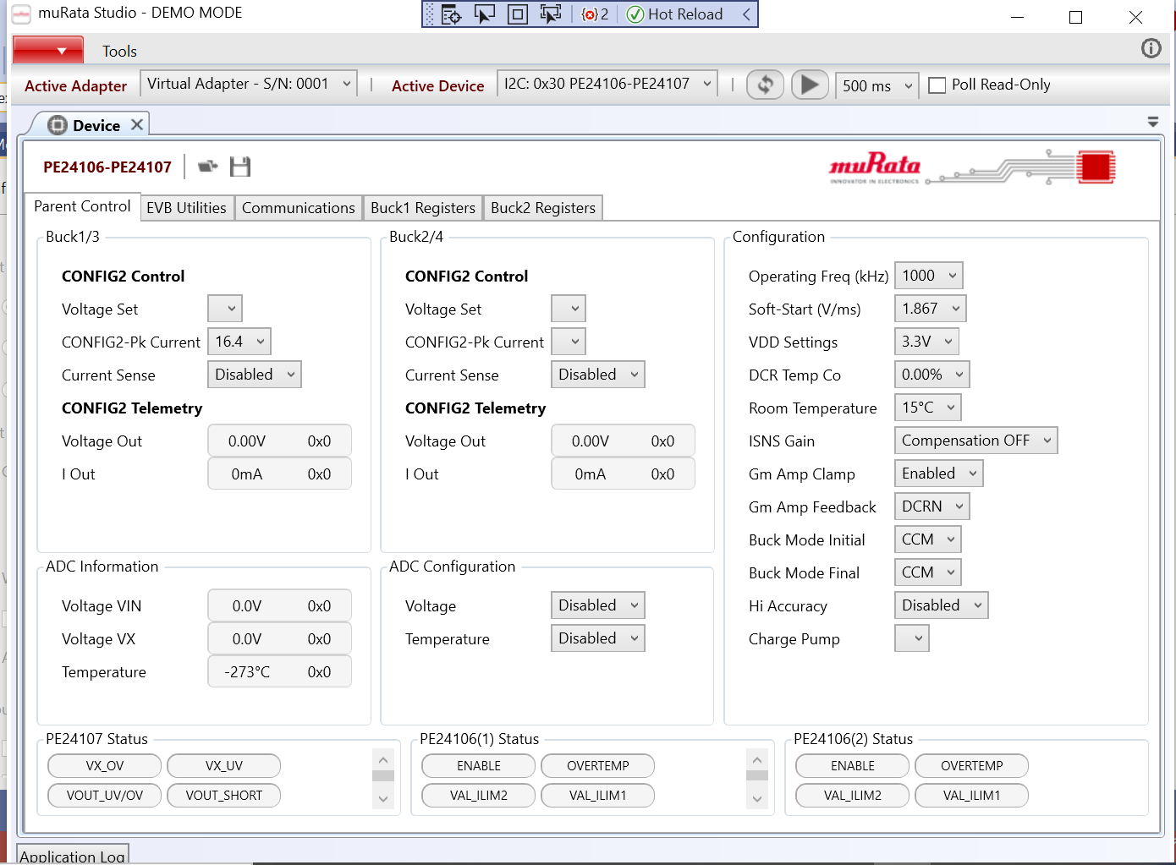

**3) PE25202-R01**

**Device Plugin Used:**

* No UI plugins

**GUI Panels:**

* Command
* Status
* Configuration

**Visual Appearance :**